CIS40A Lab 5-2: Install DHCP Server Role on Windows Server 2019

In this lab, we will install Dynamic Host Control Protocol server role on Windows Server 2019 using Windows Server 2019 Virtual Machine (VM). You can use the external hard drive that contains VM or download the VM to be loaded in VirtualBox application.
You will need an external hard drive containing CIS40AServerVM from the instructor.

Install DHCP on Windows Server 2019 Standard Edition
A Dynamic Host Configuration Protocol (DHCP) server is a network server that automatically assigns IP addresses and other network parameters to devices on a network. DHCP servers use a pool of IP addresses that they lease to clients, and the addresses are returned to the pool when they are no longer in use.
The DHCP server maintains a pool of IP addresses and leases an address to any DHCP-enabled client when it starts up on the network. Because the IP addresses are dynamic (leased) rather than static (permanently assigned), addresses no longer in use are automatically returned to the pool for reallocation. The network administrator establishes DHCP servers that maintain TCP/IP configuration information and provide address configuration to DHCP-enabled clients in the form of a lease offer. The DHCP server stores the configuration information in a database that includes:
- Valid TCP/IP configuration parameters for all clients on the network.
- Valid IP addresses, maintained in a pool for assignment to clients, as well as excluded addresses.
- Reserved IP addresses associated with DHCP clients. This allows consistent assignment of a single IP address to a single DHCP client.
- The lease duration, or the length of time for which the IP address can be used before a lease renewal is required.
A DHCP-enabled client, upon accepting a lease offer, receives:
- A valid IP address for the subnet to which it is connecting.
- Requested DHCP options, which are additional parameters that a DHCP server is configured to assign to clients.
- Some examples of DHCP options are Router (default gateway), DNS Servers, and DNS Domain Name.

Procedures
- Connect the external USB hard drive and copy-paste CIS40AServerVM from externa hard drive to the Desktop of the PC.
- Open VirtualBox app and click Tools, then click +, then locate CIS40AServerVM from the Desktop.
- In VirtualBox Manager, click Settings (orange gear), then click Network.
- On the drop down menu, click Host Only Adapter and click OK.
- Click à Start button to launch VM.
- Click Input and select Insert Ctrl+Alt+Del
- Login Windows Server 2019, password: CIS40A!
- On Server Manager, click Local Server tab, then click IPv4 address next to Ethernet.
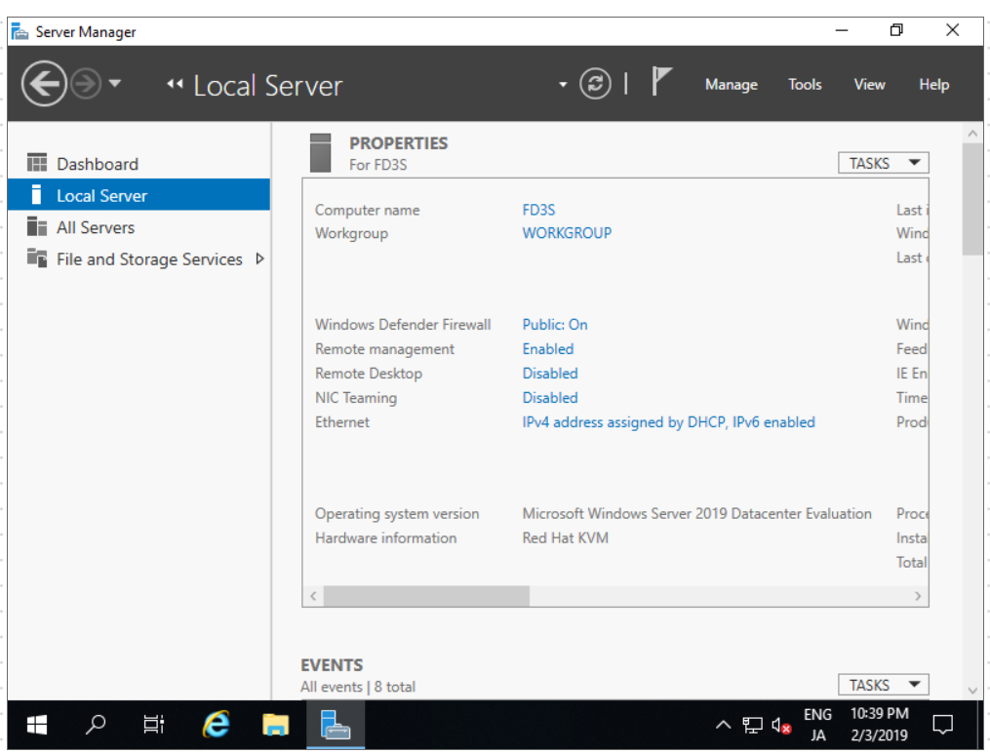
- Right-click Ethernet icon and open Properties.
- Select Internet Protocol Version 4 and click Properties button.
- Enter or verify IP address with Use the following IP address option selected. Change x to a value between 100-252
IP Address: 172.16.0.x
Subnet mask: 255.255.0.0
Default gateway: 172.16.0.1

- Click Use the following DNS server addresses, then enter the IP address (172.16.0.x) from the previous step.
  - Take a screenshot for lab submission.
  - What class is the IP address? Class B
  - Why do we use the IP address as the preferred DNS server IP address? So that the server will be looked at to offer addresses to other clients.

- Click OK to close the IP address properties window. Close the Ethernet Properties and Network Connections windows.
- On Server Manager, click Add Roles and Features.
- Review the requirements and click Next.
- Confirm Role-based or feature-based installation. Click Next.
- Select the server and click Next.
- Select DHCP Server. Then, Click Add Features button to include DHCP features in the installation.
- Click Next button to proceed.
- Review information about DHCP Server and answer the below question.
- Before you install DHCP Server, what should be included in the plan? At least 1 Static IP Address, Subnets, Scopes, and Exclusions. Then store the plan in a safe place.

- Click Next, then click Install.
- Wait for the installation to complete, then click Close.
- Click on Tools, then select DHCP to open DHCP management console.
- Click on the server to see IPv4 and IPv6.
- Right-click IPv4 and select New Scope. Then, click Next.
- Enter scope name that pertains to network segment, location, such as Branch1, HQ…
- Enter starting IP address of the scope.
If your IP address is 172.16.0.23, you should use the range that is in this subnet, such as 172.16.0.50 – 172.16.0.70.
- Enter the ending IP address of the scope. Click Next.
- Enter exclusion IP addresses. This group of address is within the scope range and will not be assigned as they are reserved for systems or dedicated devices. Click Add and Next.
- Enter the lease period, such as 27 – 30 days. Click Next.
- Confirm the selection: Yes, I want to configure the option now, click Next.
- Add Router IP address: 172.16.0.1, click Add then click Next.
- Confirm parent domain name and DNS IP (same as system IP), then click next.
- Enter WINS server IP, which can be the same or another system. Click Add, then click Next.
- Keep the preselected option, Yes, I want to activate scope now, then click Next.
- Click Finish.
- On the left pane, right-click the server and select Authorize. This allows the system to assign IP address.
- Click on Scope and open Address Pool folder. Take a screen capture showing IP pool.
- Click Scope Options.
- Take a screen capture for lab submission.

- Right-click on Policies, select New Policies, enter name Intra-client, then click Next.
- Click Add and select Vendor, Windows 2000 option
- Select Value as Default Routing and Remote Access. – SKIP THESE STEP 42 – 50.
- Click Add, then click Next.
- Enter the range within the scope.
- Select Non-local Source Routing.
- Click Next and Finish.
- Right-click Server Options, select Configure Options.
- Select Time Server, DNS Server.
- Enter option value information.
- Click Filter and verify that Allow is enabled.
- Right-click IPv6 and choose New Scope. Click Next. – Continue from #41.
- Enter the scope name, then click Next.
- Enter prefix: 2603::
- Enter the starting IPv6 for exclusion, such as 4567, then click Add.
- Enter the Preferred Life time: 60 days.
- Enter Valid Life Time: 50 days.
- Click Next to activate scope.
- Take a screen capture of activated scope.
- Close management consoles and shutdown the VM.
- Answer the following questions:
  - Upon completion of this lab, what did you learn? I learned how to set up and configure a DHCP server with both IPv4 and IPv6 addresses, and scopes for each.

  - How can you apply the learned concepts, such as DHCP configuration in your IT or cybersecurity career? A properly configured server will limit the ability of outside attackers to gain unauthorized access to a network by limiting the number of addresses that can be assigned.

- Eject the external hard drive and return the drive to the instructor.
- Login to Canvas and submit a document that contains lab question, answers and screen captures.
- Close all applications and shut down the computer.

